1. Write a Java program to print "Hello, World!" to the console

Code:

package HelloWorld;

public class HW {

public static void main (String [] args) {

System.***out***.println("Hello, World!"); //printing statement

}

}

Output:

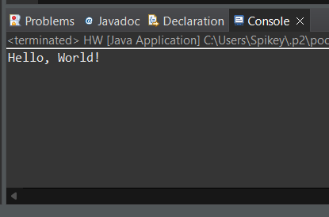

1. Write a program to find the sum of two numbers entered by the user.

Code:

package Addition;

import java.util.Scanner;

public class Add {

public static void main(String[] args) {

Scanner scanner = new Scanner(System.***in***);

System.***out***.println("Enter the first number:");

int num1 = scanner.nextInt(); //num1 as an integer

System.***out***.println("Enter the second number:");

int num2 = scanner.nextInt(); //num2 as an integer

int sum = num1 + num2; //sum as an integer

System.***out***.println("The sum is: " + sum);

scanner.close();

}

}

Output:

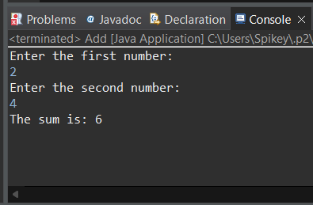

1. Write a Java program to check whether a given number is even or odd

Code:

package Even_Odd; //package name as "Even_Odd"

import java.util.Scanner;

public class EO { //public class named EO

public static void main(String[] args) { //main method

Scanner sc =new Scanner(System.***in***); //scanner object to read input

System.***out***.print("Enter a number ="); //user to enter a number

int num = sc.nextInt();

if (num % 2 == 0) //Checking the number is even by dividing by 2

System.***out***.println("Entered number is even = "+num); //message display if even

else

System.***out***.println("Enter number is odd ="+num); //message display if odd

}

}

Output: EVEN

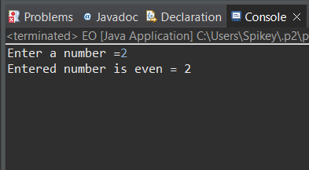

Output: ODD

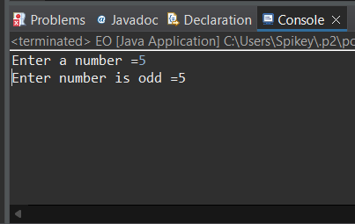

1. Write a java program to find greatest of 2 numbers

Code:

package Greatest2Numbers;

import java.util.Scanner;

public class G2N {

public static void main(String[] args) { //main method

Scanner scanner = new Scanner(System.***in***); //creating a scanner object

System.***out***.print("Enter the first number: "); //user to enter the first number

int num1 = scanner.nextInt(); //read first number entered by the user

System.***out***.print("Enter the second number: "); //user to enter the second number

int num2 = scanner.nextInt(); //read the second number entered by the user

int greatestNumber; //declared a variable to store the greatest number

if (num1 > num2) { //checking which number is greater

greatestNumber = num1; //If num1 is greater, assign it to greatestNumber

} else {

greatestNumber = num2; //If num2 is greater or they are equal, assign num2 to greatestNumber

}

System.***out***.println("The greatest number is: " + greatestNumber); //d isplay the greatest number

scanner.close();

}

}

Output:

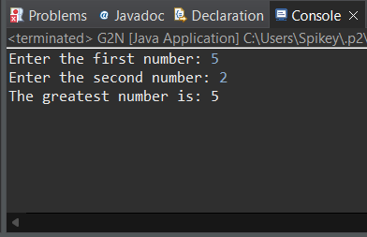

1. Write a program to implement a basic calculator that takes input as a string expression and evaluates it

Code:

package BasicCalculator;

import java.util.Scanner;

public class Calculator {

public static void main(String[] args) {

Scanner scanner = new Scanner(System.***in***);

System.***out***.print("Enter expression: ");

String expression = scanner.nextLine(); //read expression from the user

double result = *evaluateExpression*(expression); //evaluate the expression

System.***out***.println("Result: " + (int)result);

scanner.close();

}

public static double evaluateExpression(String expression) {

String[] tokens = expression.split(" ");

double num1 = Double.*parseDouble*(tokens[0]);

double num2 = Double.*parseDouble*(tokens[2]);

String operator = tokens[1]; //get the operator from the second token

double result = 0;

// Perform the operation based on the operator

switch(operator) {

case "+":

result = num1 + num2;

break;

case "-":

result = num1 - num2;

break;

case "*":

result = num1 * num2;

break;

case "/":

if (num2 != 0) {

result = num1 / num2;

} else {

System.***out***.println("Error: Division by zero");

}

break;

default:

System.***out***.println("Error: Invalid operator");

}

return result;

}

}

Output:

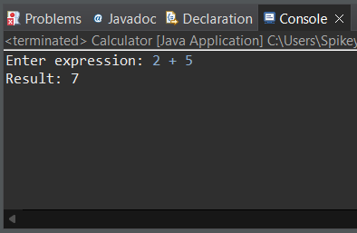

1. Create a Java program that compares two numbers and prints the larger one.

Code:

package Compare2NumberToPrintLargeOne;

import java.util.Scanner;

public class C2NTPLO {

public static void main(String[] args) {

Scanner scanner = new Scanner(System.***in***);

System.***out***.print("Enter the first number: "); //user to enter the first number

int num1 = scanner.nextInt();

System.***out***.print("Enter the second number: "); // user to enter the second number

int num2 = scanner.nextInt();

// Comparing two numbers and printing the larger one

if (num1 > num2) {

System.***out***.println("The larger number is: " + num1);

} else if (num2 > num1) {

System.***out***.println("The larger number is: " + num2);

} else {

System.***out***.println("Both numbers are equal.");

}

scanner.close();

}

}

Output: Larger number

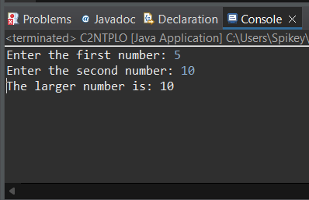

Output: Equal number

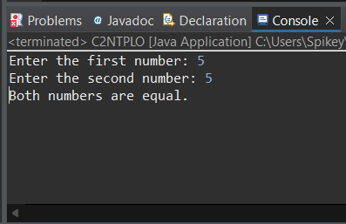

1. Write a Java program that takes an age input from the user and determines if they are eligible to vote (considering the legal voting age)

Code:

package EligibleToVote;

import java.util.Scanner;

public class ETV {

public static void main(String[] args) {

Scanner scanner = new Scanner(System.***in***);

System.***out***.print("Enter your age: "); //user to enter their age

int age = scanner.nextInt();

int legalVotingAge = 18; //legal voting age

// Check if the user's age is greater than or equal to the legal voting age

if (age >= legalVotingAge) {

System.***out***.println("You are eligible to vote.");

} else {

System.***out***.println("You are not eligible to vote.");

}

scanner.close();

}

}

Output:

